GULF INTERNET EXCHANGE POINT

Presented By:
Saleem Al Balooshi

- Introduction:

Currently all the Internet traffic between the ISP's in the GCC countries are exchanged through their providers outside the GCC countries either Europe or us except the ISP's connected to EMIX which exchange their traffic locally through EMIX POP in UAE, those ISP's are:

- OMANTEL .OM
- QUALITYNET .KW
- KEMS .KW
- EIM .AE
- DUBAI INTERNET CITY .AE

2.0 Peering Advantages:

Following are the advantages for localizing the traffic exchanged between the ISP's in the GCC countries:

2.1 Improve in Performance:

Improve the performance for the regional contents, which will increase number of hits to the E-commerce sites in the GCC countries. In addition, it will reduce delay, which has significant impact on real time applications.

2.2 Cheaper in cost:

Reduce the cost for the traffic exchange between the ISP's in the GCC countries.

2.3 Higher Security level:

Security since the traffic will not pass through 3rd party ISP.

- Peering Options:

Localizing the traffic can be achieved in one of the following options:

- Option 1: point to point peering between the ISP's in the region: In this option each ISP requires private connectivity to all other ISP, and each ISP will handle his half cct. part.

- Option 2: establish an exchange point: In this option all the ISP's should agree in a specific location where layer 2 switch will be located and each ISP will bring his own router to the exchange point and connect an Ethernet interface to the layer 2 switch, and ISP should arrange for the required capacity from their backbone to his router at the exchange point and establish an EBGP bilateral Peering with other participants in the exchange point.

- Recommendations:

The most cost effective and practical option is option 2,
Following are the action points required to achieve this option:

- All the "ISP's" in the GCC has to agree on the peering point. (UAE is the most practical and cost effective option for all the GCC since it's has direct connectivity with all the countries).
- Request for proposal from the interesting body’s to operate the Gulf-IX.
- Arrange for one cabinet and two 10/100 layer 2 switches in the agreed peering point.
- Funding of Option 2.
- The ISP's member is the Gulf-IX has to locate their routers at the agreed peering point and arrange for a back whole link to their backbone.
- The peering should not be limited only to the ISP's in the GCC countries; big corporations/organizations might as well participate.

CURRENT CONNETIVITY BETWEEN
GCC COUNTRIES

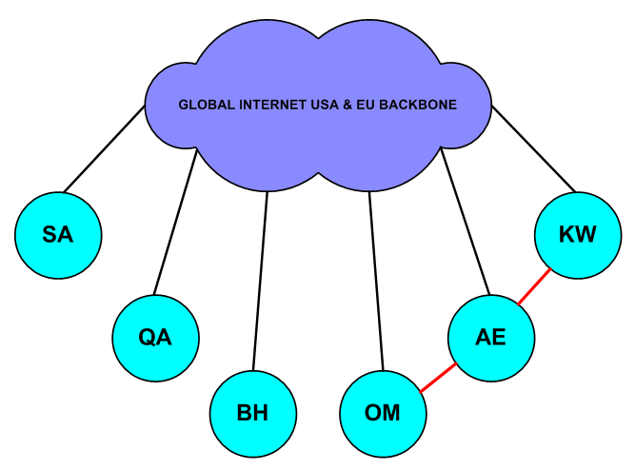

Peering Option I

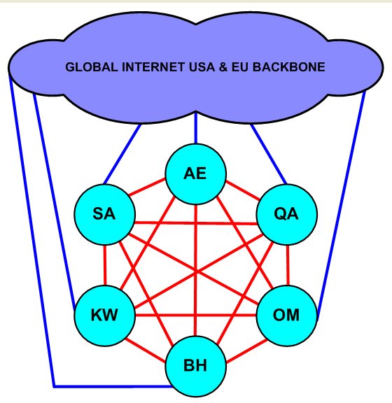

Peering Option II

